Practical 10
Part A
1) | Thread-pool runner: with a fixed pool of 3 (ExecutorService), submit about 10 Runnable  tasks that print their id and sleep briefly; shut down and await completion, observing the  few threads being reused.
 | PoolDemo.java
Code | import java.util.concurrent.*;  public class PoolDemo {  public static void main(String[] args) throws Exception {  ExecutorService pool = Executors.newFixedThreadPool(3);  for (int i = 1; i <= 10; i++) {  final int id = i;  pool.execute(() -> {  System.out.println("Task " + id + " " + Thread.currentThread().getName());  try { Thread.sleep(100); }  catch (InterruptedException e) { Thread.currentThread().interrupt(); }  });  }  pool.shutdown();  if (!pool.awaitTermination(1, TimeUnit.MINUTES)) { pool.shutdownNow(); }  }  }
Output | 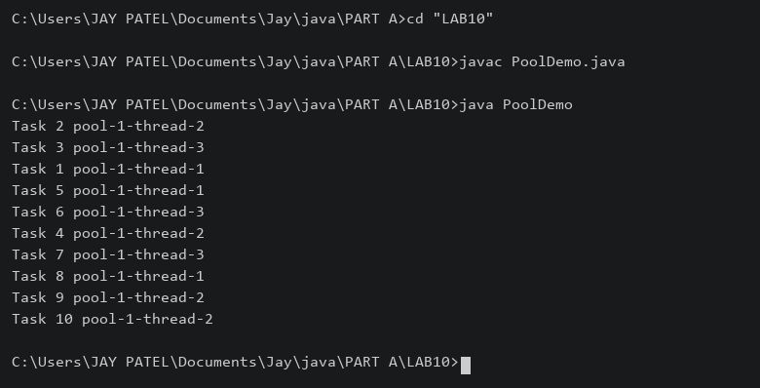

2) | Producer–consumer: one thread adds numbers to a small shared buffer and another  removes them, coordinated with wait()/notify(); produce and consume a fixed number of  items in order with none lost.
 | BufferDemo.java
Code | class Buffer {  private int value;  private boolean full;  synchronized void put(int n) throws InterruptedException {  while (full) { wait(); }  value = n; full = true;  System.out.println("Produced: " + n); notify();  }  synchronized int take() throws InterruptedException {  while (!full) { wait(); }  int n = value; full = false;  System.out.println("Consumed: " + n); notify(); return n;  }  }  public class BufferDemo {  public static void main(String[] args) throws Exception {  Buffer buffer = new Buffer();  Thread producer = new Thread(() -> {  try { for (int i = 1; i <= 5; i++) { buffer.put(i); } }  catch (InterruptedException e) { Thread.currentThread().interrupt(); }  });  Thread consumer = new Thread(() -> {  try { for (int i = 1; i <= 5; i++) { buffer.take(); } }  catch (InterruptedException e) { Thread.currentThread().interrupt(); }  });  producer.start(); consumer.start(); producer.join(); consumer.join();  }  }
Output | 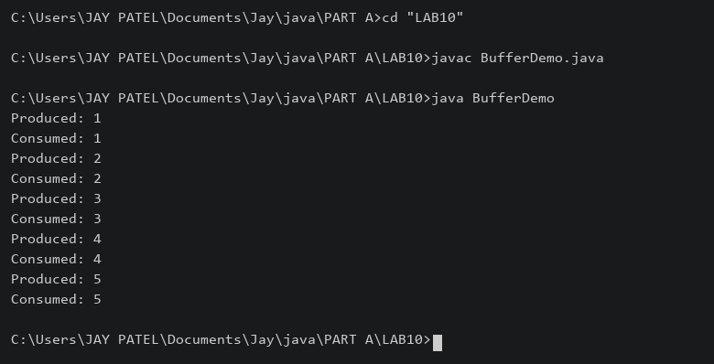

3) | (For Advanced Learners – home) Reproduce a deadlock between two threads that lock  two objects in opposite order, then remove it with a consistent lock order. Choose the  scenario yourself.
 | LockDemo.java
Code | import java.util.concurrent.CountDownLatch;  public class LockDemo {  static void pause() {  try { Thread.sleep(50); }  catch (InterruptedException e) { Thread.currentThread().interrupt(); }  }  static void lock(Object a, Object b) {  synchronized (a) { pause(); synchronized (b) { System.out.println("Completed"); } }  }  public static void main(String[] args) throws Exception {  Object a = new Object(), b = new Object();  if (args.length > 0 && args[0].equals("deadlock")) {  CountDownLatch held = new CountDownLatch(2);  Runnable first = () -> {  synchronized (a) {  held.countDown();  try { held.await(); } catch (InterruptedException e) { return; }  synchronized (b) { System.out.println("A then B"); }  }  };  Runnable second = () -> {  synchronized (b) {  held.countDown();  try { held.await(); } catch (InterruptedException e) { return; }  synchronized (a) { System.out.println("B then A"); }  }  };  new Thread(first).start(); new Thread(second).start();  } else {  Thread t1 = new Thread(() -> lock(a,b));  Thread t2 = new Thread(() -> lock(a,b));  t1.start(); t2.start(); t1.join(); t2.join();  }  }  }
 | java LockDemo deadlock deliberately hangs; stop it with Ctrl+C. java LockDemo runs the fixed version.
Output | 

